Waterwatch
Litter Trackers: reducing littering by education

Secondary education resources

Introduction
Our city’s rivers and creeks receive stormwater that runs off roofs and roads in urban areas. This stormwater often contains litter carried from Melbourne’s streets. Once it enters the drainage system, it is transferred through a series of pipes into local wetlands, creeks and rivers.
Litter items may be trapped in stream-side vegetation, collected by litter traps, or transported along the waterway eventually ending up in Port Phillip Bay. Litter is a direct financial cost to local and state governments, and therefore to the community. It is also harmful to our wildlife in both freshwater and marine environments. The Victorian Government is working to reduce litter to protect our waterways and Port Phillip Bay.
Bottles containing global positioning system (GPS) trackers (pictured) were released in various creeks and rivers by schools and community groups to simulate the movement of litter through the stormwater drainage system. In all, 100 GPS-tracked bottles in 20 locations across Melbourne’s catchments have mapped precisely how litter makes its way from our streets to our beaches.
This resource is designed for students in Years 7 to 10. The case study gives an overview of the litter trackers launch and journey. Adapt the activity for your year level.
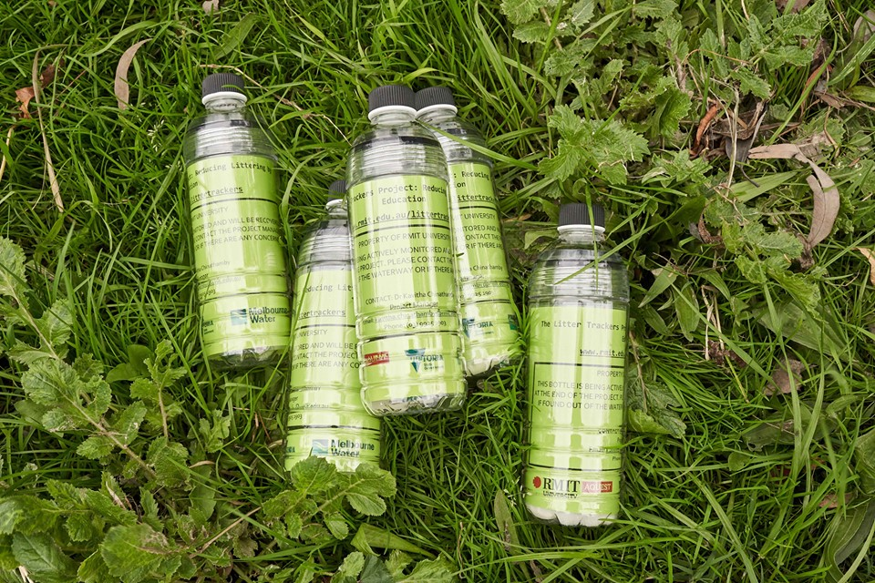
Litter Trackers bottles. Image courtesy of RMIT University.
Victorian Curriculum Year 7–8 links:

Science
Year 7 - Science understanding
Science and technology contribute to finding solutions to a range of contemporary issues; these solutions may impact on other areas of society and involve ethical considerations (VCSSU090)
Water is an important resource that cycles through the environment (VCSSU101)
Year 10 - Science understanding
The values and needs of contemporary society can influence the focus of scientific research (VCSSU116)
Global systems, including the carbon cycle, rely on interactions involving the atmosphere, biosphere, hydrosphere and lithosphere (VCSSU128)

Geography
Year 7 - Geographical concepts and skills
Collect and record relevant geographical data and information from useful primary and secondary sources, using ethical protocols (VCGGC102)
Geographical knowledge - Ways that flows of water connect places as they move through the environment and the ways this affects places (VCGGK106)
Year 10 - Geographical concepts and skills
Identify, analyse and explain significant interconnections within places and between places over time and at different scales, and evaluate the resulting changes and further consequences (VCGGC129)
Collect and record relevant geographical data and information, using ethical protocols, from reliable and useful primary and secondary sources (VCGGC130)
Geographical knowledge
Environmental, economic and technological factors that influence environmental change and human responses to its management (VCGGK145)

Mathematics
Year 7 - Number and algebra
Investigate, interpret and analyse graphs from real life data, including consideration of domain and range (VCMNA257)
Year 8 - Number and algebra
Plot graphs of non-linear real life data with and without the use of digital technologies, and interpret and analyse these graphs (VCMNA285)

Activity 1: GPS trackers
Students use digital technology to practise using GPS trackers.

Activity 2: Measuring time and distance
Students use a tape measure then apps to measure the distance of moving things in the school yard and online.

Activity 3: Plotting the journey
Students plot the journey of litter tracker bottles and find out how the urban water cycle impacts the movement of litter.

Activity 4: Investigation
Students investigate their local waterway and land use over time.

Activity 5: Call to action
Students research campaigns that highlight the importance of a national approach to litter awareness.

Case study
Schools and community groups released bottles with GPS litter trackers at different sites. Each group released five trackers which were monitored for four weeks before being collected.
The table below details three of the releases (in May 2019) including the school and community groups, tracking data, waterway, location, date and weather. Five litter trackers were released from each site.
School/community group | Waterway and general movement of tracker | Release location | Release date | Weather
Bentleigh West Primary School  First Friends of Dandenong Creek | Dandenong Creek  Trackers travel short distances and have less stops.  Tracking data | Vermont | 28 May 2019 | Top temperature: 15.7⁰C  Rain: 0.2 mm  Sun: 0.2 hours  Wind:  9am N 19 km/hr  3pm N 9 km/hr
Antonine College  Merri Creek Management Committee  Waterwatch | Merri Creek  Trackers travel long distances quickly. Can go back and forth (back up the Yarra River).  Tracking data | Brunswick East | 31 May 2019 | Top temperature:  14.3⁰C  Rain: 1.4 mm  Sun: 1.1 hours  Wind:  9 am SW 9 km/hr  3 pm SSW 9 km/hr
Our Lady of the Nativity Primary School | Maribyrnong River  Trackers travel long distances quickly. Can go back and forth (back up the Maribyrnong River).  Tracking data | Aberfeldie | 31 May 2019 | Top temperature:  14.3⁰C  Rain: 1.4 mm  Sun: 1.1 hours  Wind:  9 am SW 9 km/hr  3 pm SSW 9 km/hr
Over the next four weeks, the litter trackers travelled along the waterway. Some found their way out into Port Phillip Bay.
Figure 1 shows the journey of one bottle from the Dandenong Creek release. You can also view this tracking data in an interactive Dandenong Creek Google map. Each dot shows where the litter tracker stopped and how far it moved within four weeks. More maps from the first launch can be found in Appendix 1.

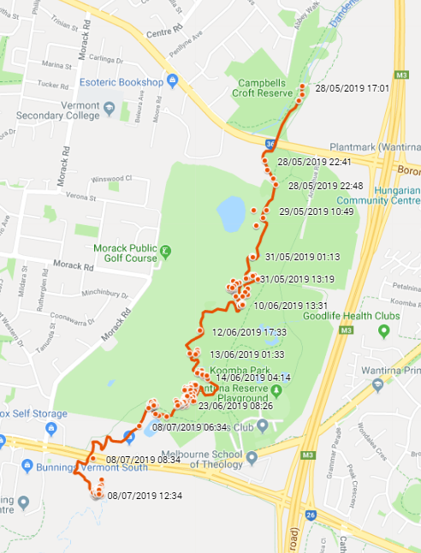
Figure 1. Dandenong Creek Bottle 1, released 28 May 2019.
Rainfall impacts the river level and flow of each waterway. Figure 2 shows the rainfall during the month of June at each launch site. It also includes the monthly average for June at that site.
Location | Monthly rainfall (mm) June 2019 | Average rainfall (mm) June
Dandenong Creek, Vermont | 51.6 | 66.8
Merri Creek, Brunswick East | 51.6 | 56.0
Maribyrnong River, Aberfeldie | 52.2 | 40.7
Figure 2. Rainfall at launch sites June 2019. Source: Rainfall and river levels, Melbourne Water
Tracking data
While the trackers were in the waterways, their data was documented using Google Maps. You can follow their complete journey using the Dandenong Creek Google map. Each time a tracker completed a trip, the red dot appeared on the map as a trajectory. A ‘trip’ is when the tracker moves and then stops. The map allows you to select ‘street map’ (see Figure 3) or ‘satellite image’ (see Figure 4) view.
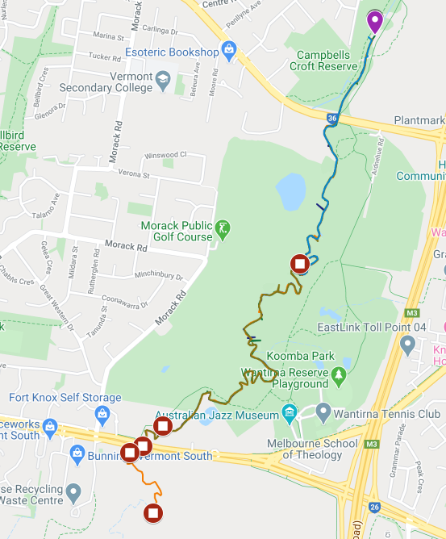
Figure 3. Street map view of the journey of the Dandenong Creek litter trackers, released 28 May 2019.
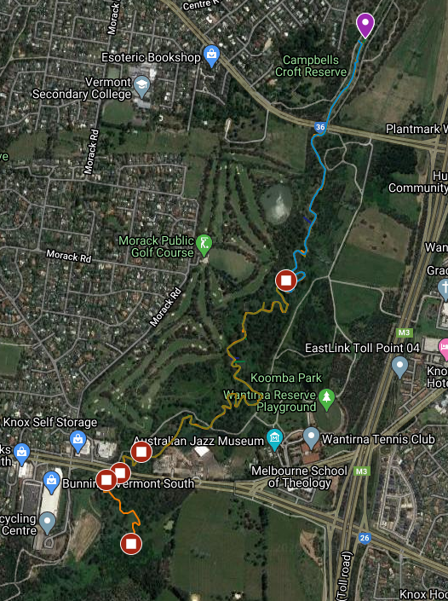
Figure 4. Satellite image of the journey of the Dandenong Creek litter trackers, released 28 May 2019.

The Litter Trackers project has now ended. Watch the following videos which show the beginning to end journeys of the GPS litter trackers, documented during the project, along four of Melbourne’s waterways.
- Dandenong Creek
- Elster Creek
- Maribyrnong River
- Merri Creek

You can also view the complete tracking data and interactive google maps of each waterway where litter trackers were released on the RMIT Litter Trackers web page under ‘Tracking data’.
According to the Keep Australia Beautiful National Litter Index (2017/2018), the top 10 most littered items nationally are:
1. Cigarette butts (and their packaging)
2. Plastic snack bags and confectionary wrappers
3. Plastic straws
4. Plastic bottle tops
5. Metal bottle tops and can ring pulls
6. Carbonated soft drink and flavoured water in cans
7. Paperboard cups and paperboard takeaway food containers
8. Plastic takeaway containers and plastic cups
9. Paper shopping dockets and shopping lists
10. Paperboard coffee cups.
This rubbish enters our waterways every day, taking a similar journey to the litter tracker bottles.
The following activities incorporate information from the case study, data from the litter trackers map and real-life learning to assist students in understanding the litter trackers project and the problem of litter in our waterways.

Activity 1: GPS trackers

Students use apps and other digital technology to practise using GPS.
Equipment
For the teacher:
Smartboard or TV connected to the internet
The Litter Trackers website
How do GPS work? video [3:46] A video explaining the core idea of how GPS works.
For the student:
A tablet for each student or each group (or their own smartphone)
Preparation
Download one of the following apps to each tablet or smartphone:
- Google Maps
- My Tracks
- GPS Logger
- GPS Essentials
- Simple Logger app
Ensure location services is turned on for that app.

Activity steps
- Ask students what they already know about GPS? Why is it useful?
- Watch the How does GPS work? video [3:46]
- As a class, discuss global positioning systems (GPS). We use GPS for finding an address, calculating distance and time, exploring what is close by or when we’re walking or hiking. We can also use it for environmental purposes.
- Ask students if they can think of anything that might use GPS. For example:
- tracking trucks, shipments, animals (see the Arthur Rylah Institute project Tracking eel migration using satellites)
- surveying
- driving to an unknown place
- planning holidays.
- Using a tablet or smartphone app such as Google Maps, My Tracks, GPS Logger, GPS Essentials or Simple Logger, students practise using GPS around the school yard. They can watch their movements in real time. They can practise finding directions from one point to the next, measure distance and plot journeys.
- Back in the classroom, students draw a map of their walk around the school with pencil and paper. They should include basic cartographic conventions such as border, orientation, legend, title, scale and source.
- Introduce the Litter Trackers project and case study to students. Display the Litter Trackers website and watch one of the Litter Tracker journey videos. Discuss the benefits of finding out where our litter ends up.

Years 9 and 10 extension
- What information are researchers expecting to find from the litter tracker bottles’ movements?
- How can this inform decision making?
- What implications do the findings have for future management? (e.g. extra signage, education to stop people littering.)

Activity 2: Measuring time and distance
Students use digital and practical methods to measure the distance travelled by moving things.
Equipment
For the teacher:
Smartboard or TV connected to the internet
The Litter Trackers website
For each group:
A tape measure
A ball of string
For the student:
A tablet for each student or each group (or their own smartphone)
Preparation
Download the following apps onto each tablet or smartphone:
- Google Maps
- Measure (iOS)

Activity steps
- Students use an app such as Measure (iOS) to measure classroom items (e.g. the table, the length of the room).
- Explain that we can also measure long distances with digital technology.
- Students use the Google Maps app or Google Maps on a PC/laptop to measure the distance around their classroom or a route within the school. The distance will be limited by the length of the balls of string. Refer to the following appendices for instructions on how to measure in Google Maps:
- Appendix 2. How to measure distance on Google Maps (app)
- Appendix 3. How to measure distance on Google Maps (internet)
- Working in groups, students use string and a tape measure to plot the real journey and see how closely the distances match.
- Students look at the Litter tracker project tracking data for Dandenong Creek.
- Students measure how far two trackers have moved over one month. This can be done on the app or the internet. Start at the launch site and continue until you have reached the final destination of the litter tracker bottle.
- Students also measure this distance by using the ‘Directions’ function on Google Maps. When you type in the landmark names the distance will be measured (taking the fastest route by either car, foot or public transport).
- Display the tracking data for Dandenong Creek again.
- Explain that the GPS allows us to follow the trackers’ journey. Each time a tracker completes a trip, the red dot appears on the map as a trajectory. A trip is when the tracker moves and then stops.
- The Litter Trackers project has now ended. The following videos show the beginning to end journeys of the GPS litter trackers, documented during the project, along four of Melbourne’s waterways. Choose one of these videos to show your class.
      - Dandenong Creek
      - Elster Creek
      - Maribyrnong River
      - Merri Creek
- After viewing one of the videos, choose the corresponding Tracking data and view on the smartboard.
      - Dandenong Creek
      - Elster Creek
      - Maribyrnong River
      - Merri Creek
- Discuss factors that may have affected the movements of the litter tracker bottles.

Years 9 and 10 extension
- Students take a field trip to one of the Litter Tracker launch sites. They can see where the litter tracker bottles entered the waterway. Select a litter tracker launch site from the case study (p. 4) or a litter tracker bottle from the appendices and take students along the waterway to see where it ended up. Discuss the barriers the litter tracker encountered along the way.
- Students take photos of the area.
- Use an app such as The Photo Investigator (iOS). When scrolling through photos, photos with a globe overlay have GPS metadata, so you can quickly tell which photos have GPS coordinates. Use the extension to view photo metadata from Messages, Photos and other apps.

Activity 3: Plotting the journey
Students plot the journey of the released litter tracker bottles and find out how the urban water cycle impacts on the movement of litter.
Equipment
For the teacher:
Smartboard or TV connected to the internet
Google Earth app
Google Maps street view
The Litter Trackers website
Bureau of Meteorology climate data web page
Melbourne Water natural and urban water cycle web page
For the student:
A tablet for each student or each group (or their own smartphone)
Preparation
Download the Google Earth app onto each tablet or smartphone.

Activity steps
- Choose a river and discuss how it flows through the landscape.
- Where does it start?
- Where is the source or head water?
- Revisit the ‘litter trackers’ maps in the appendices.
- Use Google Earth to track the point of launch backwards to find the beginning of the river, creek or other waterway. Imagine rain falling into the head waters area. What could happen to that one drop along the way? Some scenarios are:
- It evaporates.
- Animals drink it.
- Plants absorb it.
- The drop is extracted to irrigate crops.
- The drop stays in the waterway.
- Sediment and rubbish joins it in the waterway.
- Students use the Bureau of Meteorology climate data web page, the litter tracker maps in the appendices to see what happened to the litter tracker bottles. Match up the weather and rainfall (from launch date to end date) at the site to see if this impacted the litter tracker bottles’ movements.
- Water, and what it carries along, can get through some barriers (e.g. reeds, soil, plants) but not others (e.g. weirs, diversions, bridges). What barriers can you see from Google Earth? What is the impact of these barriers? What collects at the barriers?
- Refer to the Melbourne Water natural and urban water cycle web page to discuss the difference between the natural water cycle and the urban water cycle.
- How does water enter a waterway in the natural water cycle?
- How does it enter a waterway in a modified/urban environment?
- What does this mean for litter and pollution entering the waterway?
- What other factors impact the natural water cycle? (e.g. rain, floods, drought)
- What other factors impact the urban water cycle? (e.g. stormwater run-off, release of treated wastewater, environmental flows)
- An urban environment, through its network of stormwater drains and pipes, increases the rate of flow into a waterway. For instance, when it storms, water enters the waterway faster, more directly and in larger volumes at certain points (e.g. at a stormwater outlet).
In a natural environment, water enters the waterway in a lot of different places, usually at a slower pace. Some water infiltrates into the ground and is gradually released into the waterways.
- What are the impacts of an urban environment on the waterway?
- What are the impacts of a natural environment on the waterway?
- Students select two separate sites (preferably one urban and one natural) and one litter tracker bottle from each site in the appendices. Using Google Earth, find some explanations about why some litter tracker bottles moved further than others.
- Is the waterway surrounded by trees or grass?
- Are there houses and factories nearby?
- Can you see any boat ramps, boats or ships?
- Do the waterways travel through built up areas or bushland?
- Can you see any wetlands?
- Can you see any diversions?
- Can you see what the base of the waterway is (e.g. concrete, mud, paving etc.)?
- Is the waterway in an urban or natural environment?
- Using the rainfall charts in the case study and the maps, students compare the rainfall for each site. What effect would this have on the movement of the litter tracker bottles? (e.g. if the water dries up, the rubbish could be blown elsewhere. If the area floods, the water carries the rubbish away.)

Years 9 and 10 extension
- Urban environments often have stormwater systems that divert water to built pipes and drains lined with concrete or paved surfaces. In times of flood, this diverts water into waterways and away from homes and businesses quickly.
- Discuss how hard concrete or paved surfaces might affect the litter tracker bottles’ journeys.
- Why do we have stormwater drains? Why is this a common management technique in cities?
- Examine how the waterways are connected through the urban and the natural water cycle.
- Go to the Litter Trackers website and choose one of the sets of tracking data for a waterway. Turn on the satellite layer. Look at the launch point of one litter tracker and two other points that it has stopped.
- Compare the surroundings at each point. How are they different? How are they similar? Consider land uses e.g. housing, industry, vegetation.
- Has litter travelled further in urban environments where stormwater has entered the waterway quickly?
- Discuss how some communities/areas along the waterway might be more invested than others in keeping their patch of waterway clean. For some people, the waterway might be their playground, backyard and recreational area. For others, it might simply be an area behind their factory or place of work. Does it make a difference if the waterway is in a natural or urban environment?
- Discuss why some litter tracker bottles stop at certain points. Refer to the Dandenong Creek bottles (Appendix 1). None of these bottles travelled further than just past Bunnings in Vermont South. Why? Why are there clusters of dots (indicating movement and stops)? Use Google Earth and Google Maps street view to examine the creek at those clusters. What happens to the creek after the freeway underpass?

- Figure 6 shows the location of litter traps in Melbourne’s waterways (orange dots). Litter traps are large structures anchored in the river that collect floating rubbish. Could any of the litter tracker bottles have been caught by a litter trap?
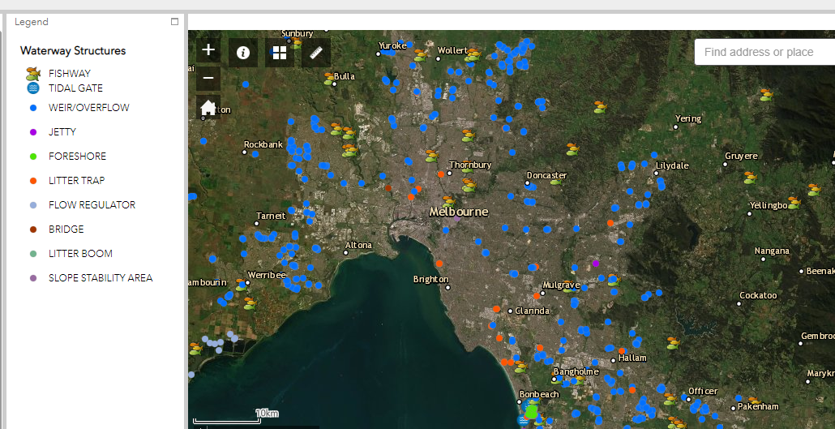
Figure 6. Location of litter traps along Melbourne’s waterways.

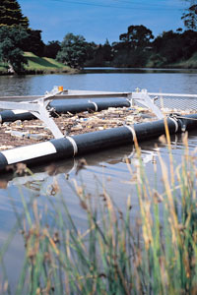
Figure 7. Litter trap

Activity 4: Investigation
Students investigate their local waterway and research what the land was used for in the past and what it is used for now.
Equipment
For the teacher:
Smartboard or TV connected to the internet
The Litter Trackers website
Historical maps of local area
Google My Maps (this requires a google account)
Scribble Maps website
NASA How to interpret a satellite image: five tips and strategies website
NatureKit map
Australian Government national map
For the student:
A tablet for each student or each group (or their own smartphone)
Preparation
Download the Google Earth app onto each tablet or smartphone.

Activity steps
- Use the litter tracker maps in the appendices to gain an insight into litter in our waterways. What assumptions can you make about how litter travels in general?
- Based on Activity 3: Plotting the journey, what would likely happen to a piece of rubbish that ended up in a waterway?
- As a class, think of a local creek, river or other waterway. If you dropped litter there, think of some answers to the following questions:
- Where would it likely end up?
- How would it get there?
- What might happen to it along the way?
- Can you think of any other scenarios?
- Using historical maps, research the variety of ways the waterway has been used by humans over time. How have these changes impacted the waterway?
- Use Google Earth to identify current land use surrounding the waterway. How has land use and population growth impacted the waterway?
- Use Google Earth to identify land use along the stretch of waterway the litter tracker bottles have travelled.
- Are there areas that have been revegetated or made into parkland?
- Does this impact where the litter ends up? (e.g. people are more likely to collect rubbish in these areas during clean-up days.)
- Using on online mapping tool such as Google My Maps or Scribble Maps, students draw a path following a significant waterway. Show the elevation profile of the waterway. Note the changing elevation and slope steepness at different locations and how this affects erosion and streamflow. How might this affect the way litter moves along the waterway?
- Consider the litter tracker bottles. A bottle was chosen because it represents a common type of plastic bottle that is discarded as litter in the environment.
- Would it make a difference to the movement of the GPS tracker if it was instead inside a plastic bag?
- What difference would the litter material make on the impacts it has on the environment? (e.g. plastic bags fly away, cigarette butts might be ingested by an animal)
- What are the environmental impacts of different types of litter? Choose one from the top ten most littered items list (p. 8) and research its impact on the freshwater and marine environments.
Years 9 and 10 extension
- Investigate the changes to your local creek, river or other waterway over time. This task could consider changes over the last 100+ years or the last 25 years.
- How have social actions (recreational activities, lobbying, clean-up days, change in attitudes) led to the waterway’s current state? (e.g. pristine, degraded or something in between.)
- View a local creek, river or other waterway on Google Earth and ask students to interpret each one using the advice from NASA.
- Select a waterway the litter trackers were released in and view the creek or river they travelled in on Google Earth. Ask students to interpret each one using the same NASA advice.
- Use the NatureKit map or the Australian Government national map to look at the distribution of environments in your local area. Also look at the waterways where the litter tracker bottles travelled.
- Discuss your findings with the class.

Activity 5: Call to action
Students research campaigns that highlight the importance of a national approach to litter awareness. They then create their own campaigns.
Equipment
For the teacher:
Smartboard or TV connected to the internet
The Litter Trackers website
For the student:
A tablet for each student or each group (or their own smartphone)
Video editing software (see Useful resources for suggestions)
Preparation
Download video editing software onto each tablet or smartphone.

Activity steps
- Students investigate campaigns such as Keep Australia Beautiful, Clean Up Australia Day and the Australian Marine Debris Initiative. See Useful resources below for the links. These are Australia-wide campaigns to educate the community about the effects of litter on our waterways and the environment and the benefits of removing litter.
- Using the Litter Trackers project information, students develop an awareness communication tool (e.g. signage, brochure, poster, digital presentation, website, video or social media ad) to let others in the community know about this important issue.
- The next step is to spread the word. Students could write a summary for the school newsletter, blog, record a podcast, organise a question and answer session or develop a short video or animation about the program and the importance of it. Be sure to include what others can do to help with the litter issue.
Years 9 and 10 extension
- Using the Litter Tracker project information, develop a campaign to get as many people (in your school and community) to help clean up the local environment. The campaign could include promoting a clean-up day at school, using lids on bins at school or monitoring the drains near school for rubbish etc.
- You will need:
- Communications tools. This could include word-of-mouth, advertising in your school newsletter, a story on the school website, a social media post or ad on your school’s page, a short video about the Litter Trackers project or your campaign posters displayed around the school.
- A clear call-to-action. What do you want people to do? What messages do you want them to learn? How do you want their behaviour to change as a result? How will you measure the results and successes of your campaign? (It could be by finding less litter in the school yard, noticing healthier waterways, conducting a litter audit, large numbers of people reached via social media etc.)
- A plan. You could run your campaign over a month and include a launch (e.g. addressing the school at assembly or posting on your school’s social media page), an event (e.g. a clean-up day) and a ‘thank you’ (e.g. morning tea for the key helpers or a note in the newsletter or on social media). Document the successes (or otherwise) of your campaign and learnings for the future.

Useful resources

AQUEST (Aquatic Environmental Stress Research Group)
The Aquatic Environmental Stress research group assesses the health of aquatic ecosystems, inland waterways and estuaries, using a weight-of-evidence approach based on environmental outcomes. The AQUEST team are involved in the Litter Trackers project.

Australian Marine Debris Initiative (Tangaroa Blue)
Tangaroa Blue Foundation is an Australia-wide not-for-profit organisation dedicated to the removal and prevention of marine debris: one of the major environmental issues worldwide.

Bureau of Meteorology
The Bureau of Meteorology is Australia's national weather, climate and water agency.

Google Maps
Google Maps is a web mapping service developed by Google. It offers satellite imagery, aerial photography, street maps, 360° panoramic views of streets, real-time traffic conditions, and route planning for traveling by foot, car, bicycle and air or public transportation.

Google Earth
Google Earth is a computer program that renders a 3D representation of Earth based primarily on satellite imagery. The program maps the Earth by superimposing satellite images, aerial photography, and GIS data onto a 3D globe, allowing users to see cities and landscapes from various angles.

Keep Australia Beautiful National Litter Index (2017/2018)
The Keep Australia Beautiful National Litter Index (NLI) is Australia’s only national, annual, quantitative measure of what litter occurs where and in what volume. Litter counts are done twice annually across 983 sites nationally to create an annual report on litter in each State and Territory that can be compared to the national average.

The Litter Trackers: Reducing littering by education
The Litter Trackers is a collaborative project between RMIT University and Melbourne Water, supported by the Victorian Government. As part of the Litter Trackers project, scientists will work with schools and community groups to launch GPS tracked bottles into Melbourne’s waterways to demonstrate how and where litter travels once it enters our waterways.

Melbourne Water
Melbourne Water is a statutory authority owned by the Victorian Government. It is their role to manage and protect Melbourne's major water resources on behalf of the community. Melbourne Water is involved in the Litter Trackers project.

National Map
National Map is an online map-based tool to allow easy access to spatial data from Australian government agencies. It was an initiative of the Department of Communications and the Arts (DCA) now currently managed by the Digital Transformation Agency (DTA) and the software has been developed by Data61 working closely with the DCA, Geoscience Australia and other government agencies.

NatureKit
NatureKit is DELWP's biodiversity web mapping and reporting tool that has been developed to replace Biodiversity Interactive Map (BIM). NatureKit displays information on Victoria's biodiversity values, investment prospects, flora and fauna distribution, native vegetation, marine bathymetry and habitat, disturbance, land administration and classification.

The Pesticide Detectives
The Pesticide Detectives is an extensive national Citizen Science project investigating the occurrence and concentrations of pesticides used in homes and gardens as well as agricultural and urban settings in Australia’s waterways.
Funded by the Department of Industry, Innovation and Business, Pesticide Detectives is a collaborative project combining the scientific expertise of RMIT University’s Aquatic Environmental Stress Research Group (AQUEST) scientists and Citizen Science volunteers in the collection of sediment samples from waterways across Australia.

Scribble Maps
With Scribble Maps you can create and share custom maps, embed maps on websites, and create images or PDF.

Video editing software
- Blender
- Lightworks
- Shotcut
- Openshot

Media links
You can follow the Litter Trackers project on Facebook: @littertrackers
The project has received widespread media coverage.
Please refer to the links below:
From the burbs to the bay: GPS tracking reveals how litter travels
A rubbish idea: GPS-tracked bottles show how litter moves through Melbourne’s waterways
Litter tracking project launches in Healesville
It’s legit, miss: The kids who litter to save the environment
Oyster2 used as ‘simulated litter’ in RMIT campaign
Tracking litter on Merri Creek
Williamstown students use the GPS bottles to track litter
Williamstown High School—Marine biology

Learn more about what is being done to stop litter
Australian Marine Debris Initiative
Tangaroa Blue Foundation is an Australia-wide not-for-profit organisation dedicated to the removal and prevention of marine debris: one of the major environmental issues worldwide
Beach Patrol
Beach Patrol is an organised network of volunteers and community beach cleaning groups who clean the beaches of Melbourne to make them safer and more enjoyable for everyone.
Clean Up Australia Day
Clean Up Australia inspires and empowers communities to clean up, fix up and conserve our environment. The website has information on clean-up events and resources about the impact of litter.
Environment Education Victoria
Environment Education Victoria (EEV) is a professional association of educators for sustainability. EEV offers membership for teachers and free classroom resources.
Keep Australia Beautiful
Keep Australia Beautiful is a national organisation that is recognised as Australia’s independent litter prevention thought and practice leader, for a litter free and sustainable Australia.
National Litter Index
A national measure of the presence of litter across the country.
Responsible Runners
An organisation that asks the community to join them across Australia for a fun 30 minute clean-up to meet like-minded people and protect our marine environment. They also help sort recyclables and collect data for the Australian Marine Debris Initiative.
Victorian Litter Action Alliance, Sustainability Victoria
Sustainability Victoria supports state and local government, land managers and other partners to address litter and illegal dumping issues.
Waterwatch Victoria
Waterwatch is a citizen science community engagement program connecting local communities with river health and sustainable water issues and management.

Appendix 1
You can also view the tracking data and journeys of the litter trackers on The Litter Trackers website.

Dandenong Creek maps
Dandenong Creek Bottle 1 journey with dates.

Dandenong Creek Bottle 2 journey with dates.

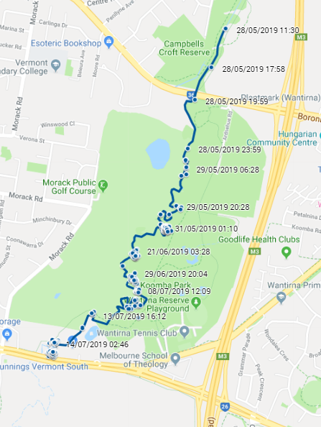

Dandenong Creek Bottle 3 journey with dates.

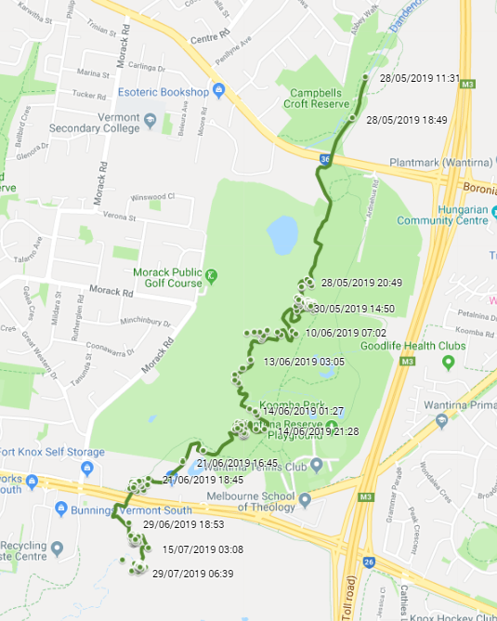

Dandenong Creek Bottle 4 journey with dates.

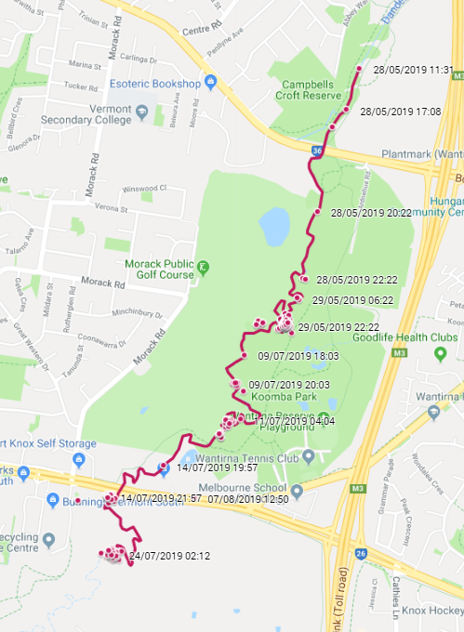

Dandenong Creek Bottle 5 journey with dates.

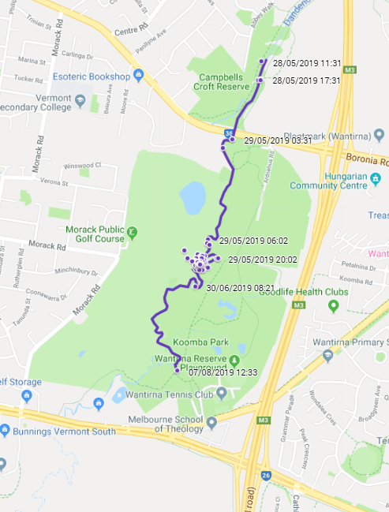

Appendix 2

How to measure distance on Google Maps (app)
Type into the search bar the name of the site (e.g. Maribyrnong River Trail).
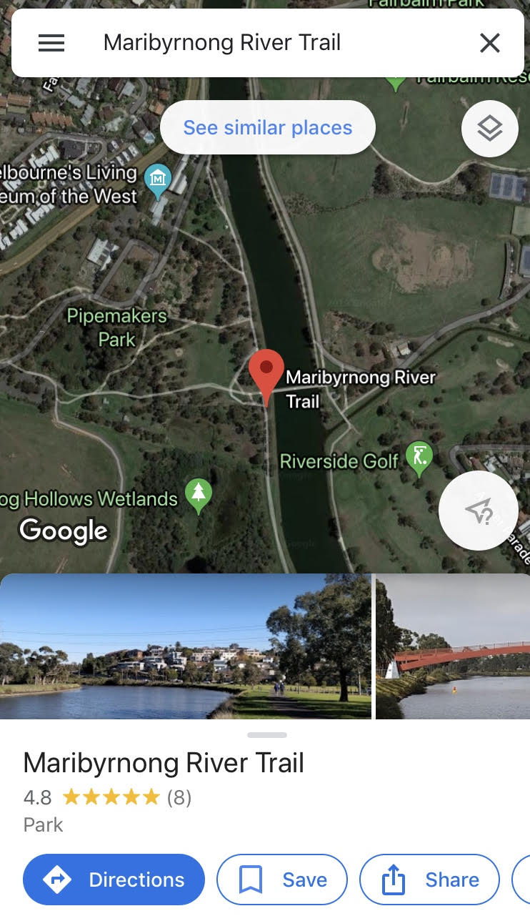

Select exact location and hold screen. Dropped pin will appear along with a red place marker. Tap the ruler ‘Measure distance’.
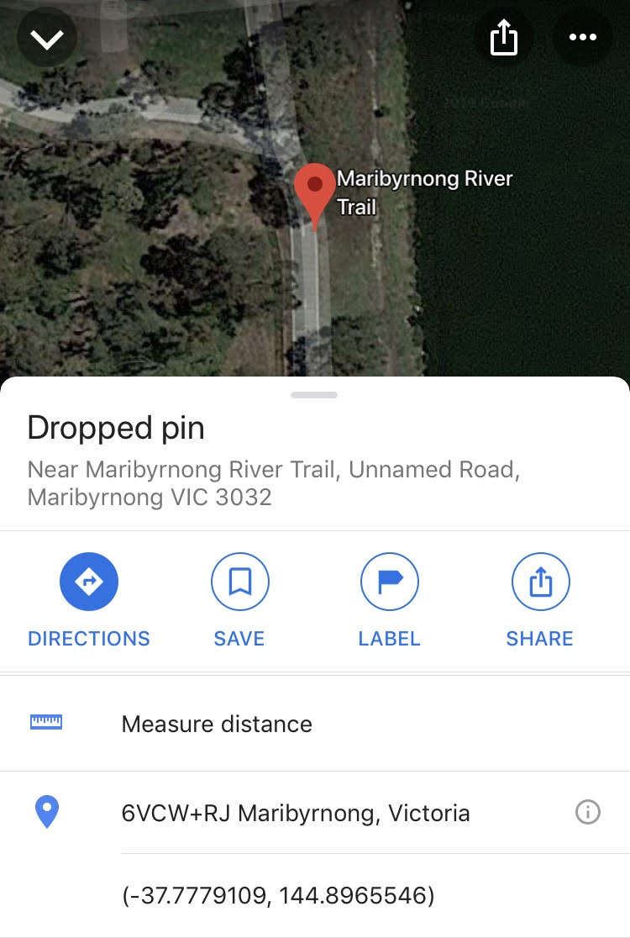

As per the instructions on the screen, drag the map and tap ‘Add point’ (plus sign inside the blue circle). The distance shows beneath.
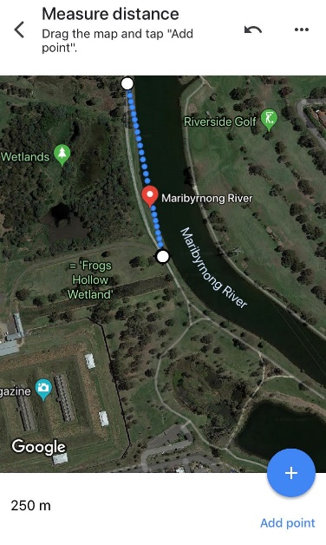

Continue adding points until you have reached the end point.

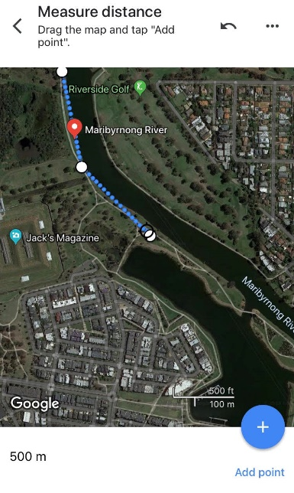

Appendix 3

How to measure distance on Google Maps (internet)
Right click on dropped pin and select ‘Measure distance’.

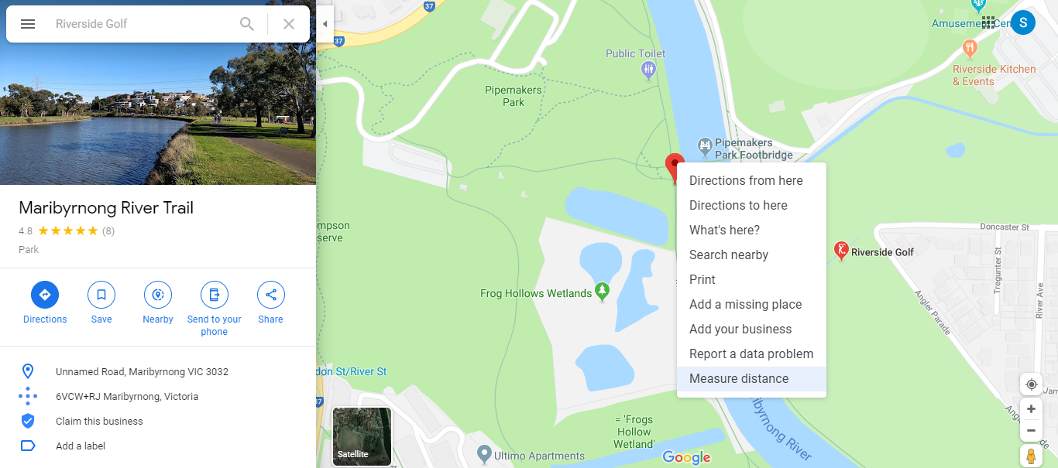

Click another location on the map and distance will show in the box.
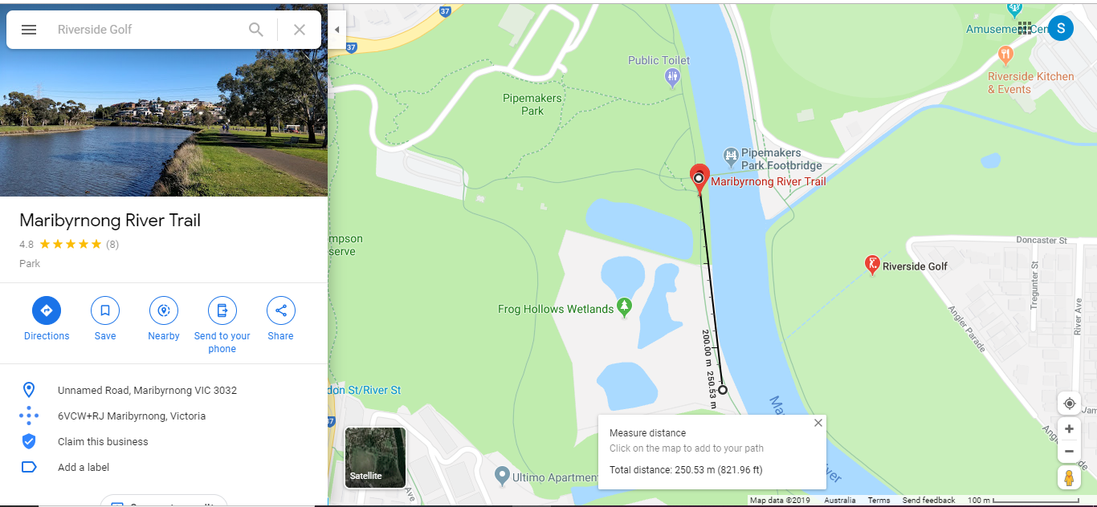
Continue adding locations to measure the full distance. Total distance is displayed in the box.
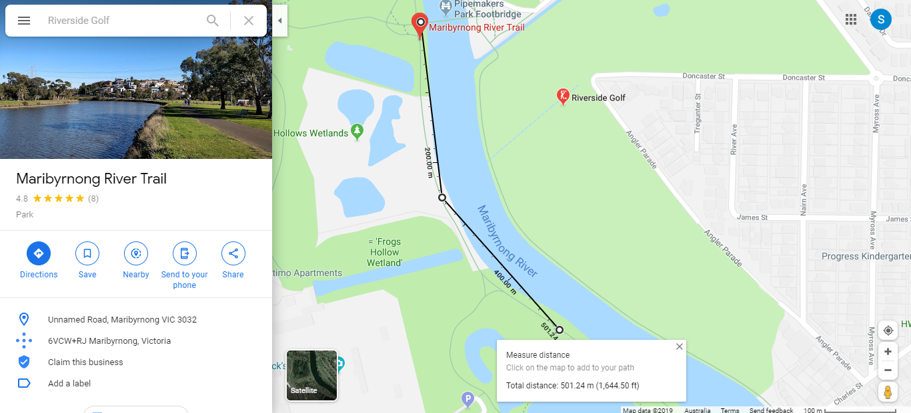

Appendix 4
Litter Trackers – Dandenong Creek | RMIT University (YouTube)
Check out our litter trackers journey through Dandenong Creek.
Litter Trackers – Elster Creek | RMIT University (YouTube)
Check out our litter trackers journey through Elster Creek.
Litter Trackers – Maribyrnong River | RMIT University (YouTube)
Check out our litter trackers journey through Maribyrnong River.
Litter Trackers – Merri Creek | RMIT University (YouTube)
Check out our litter trackers journey through Merri Creek.

Video links also available at…

https://www.rmit.edu.au/research/research-institutes-centres-and-groups/research-groups/aquest/rmit-litter-trackers

Reference
AQUEST Research Group at RMIT
AQUEST- Aquatic Environmental Stress Research Group @ RMIT University

The Victorian Curriculum F-10 content elements are © VCAA, licensed CC-BY-NC-SA. In addition to the content published on the Victorian Curriculum F–10 website, F–10 curriculum support resources can be accessed from the VCAA website. Accessed 10 September 2019.

